DETAILS OF BUS BOOKING PANEL

1.USER PANEL

2. AGENT PANEL

3. ADMIN PANEL

**1. USER PANEL:- 1. ONLINE USER SIRF TICKETS BOOK KAR SAKTA HAI**

**2. REPRINT KAR SAKTA HAI , ONLINE BOOKING ONE HOUR BEFORE BOOK KAREGA ,TICKETS CANCEL 2 GHANTE PEHLE KAR SAKTA HAI .**

**3.TICKET USER KA MAIL MAI JAYEGA AUR EK HAMARE PASS EK COPY AYEGA.**

**4.USER KE LIYE DEPARTURE TIME KE 1 GHANTA PEHLE BOOKING BAND HO JAYEGA.**

**2.AGENT PANEL:- 1. VIEW STATUS(ISME BOOKING DATE AUR JOURNEY DATE M SEARCH KARTE HAI)** 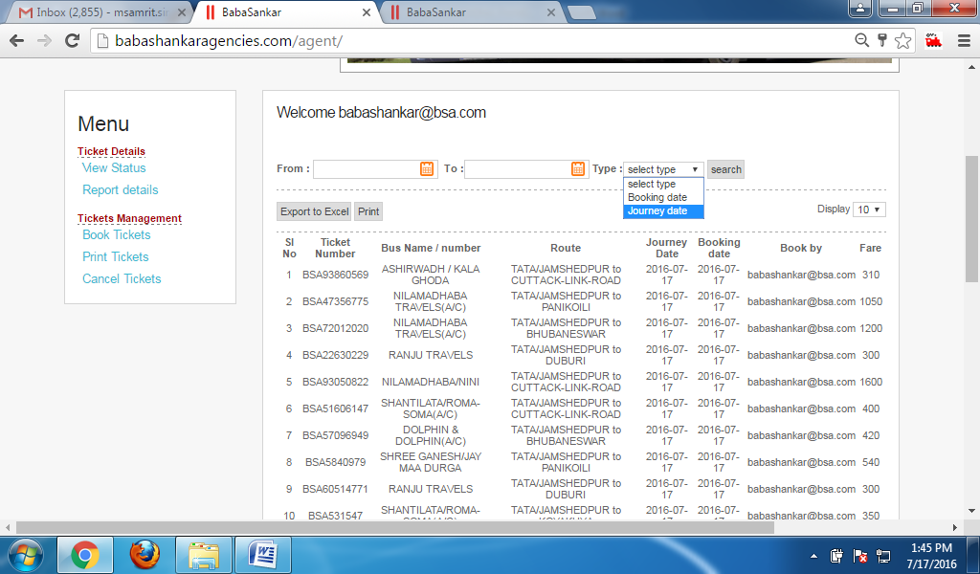

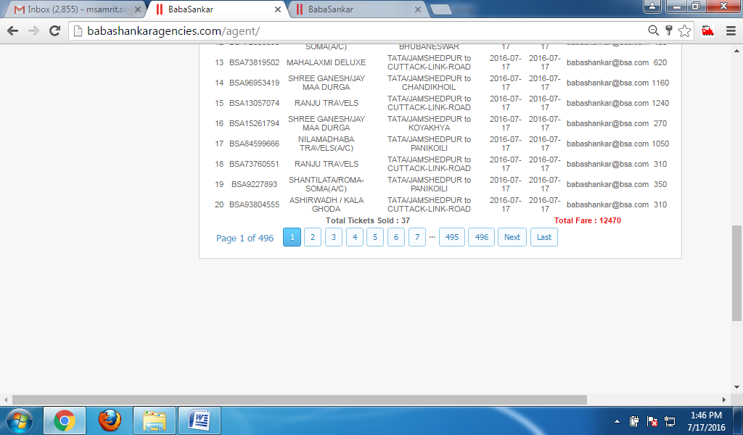

**2.PRINT TICKETS**

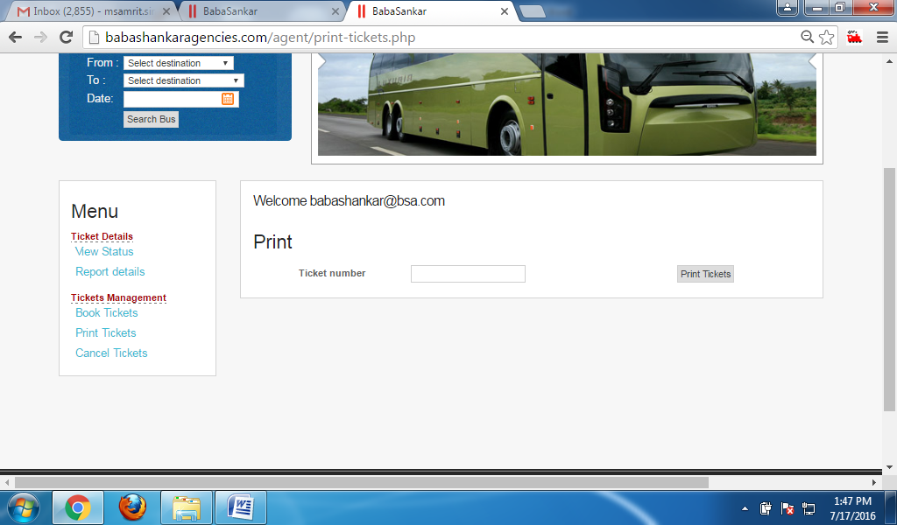

**3. AGENT SIRF APNA BOOK KIYA HUA TICKT CANCEL KAR SAKTA HAI.** 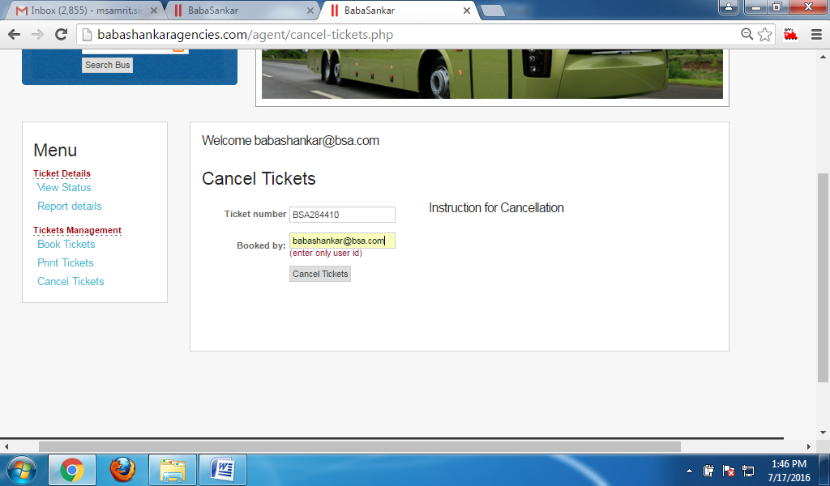

**4. REPORT DETAILS(CONDUCTOR INVOICE)** 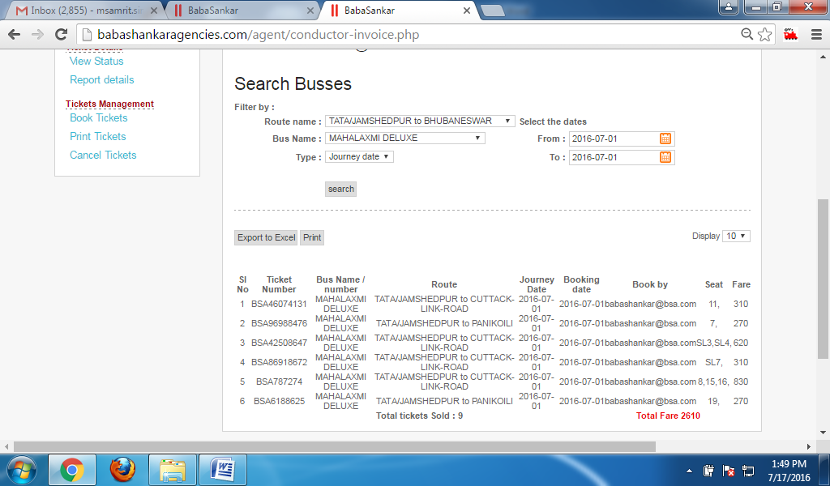

**5.END OF THE DAY REPORT**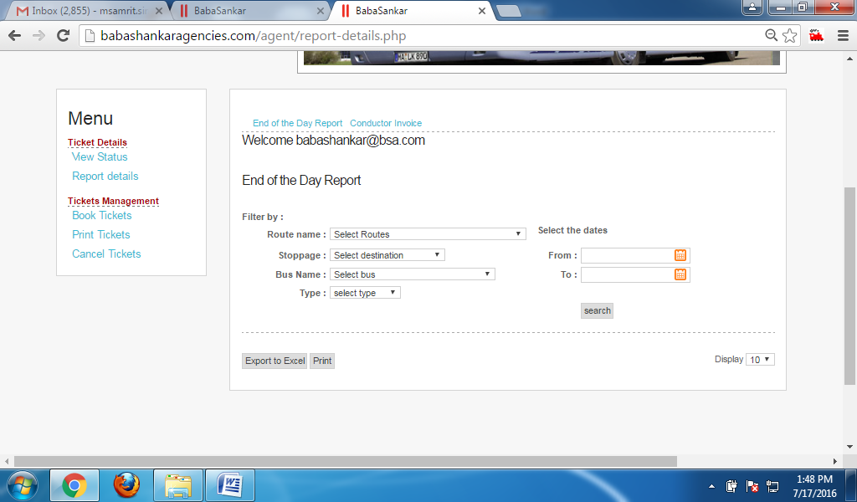

**3.ADMIN PANEL:- 1.** 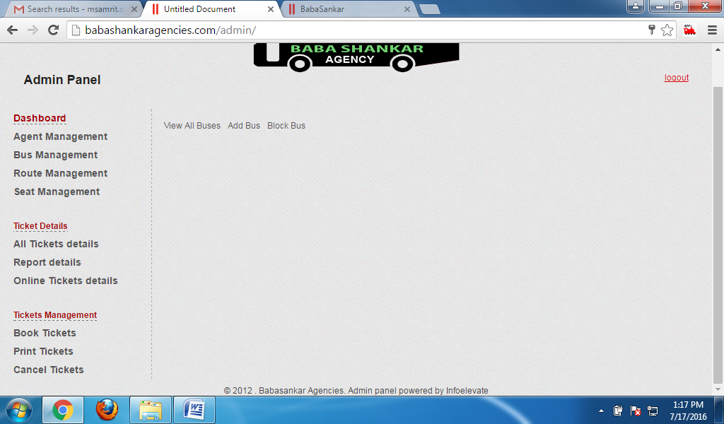

**1. AGENT MANAGEMENT**

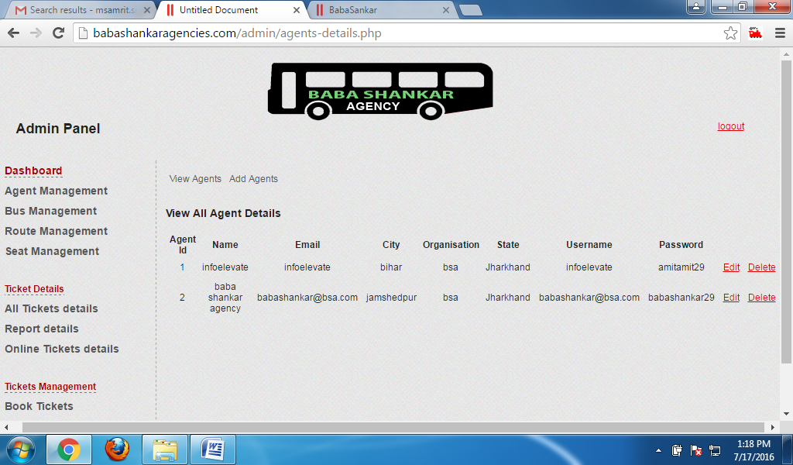

**2.BUS MANAGEMENT**

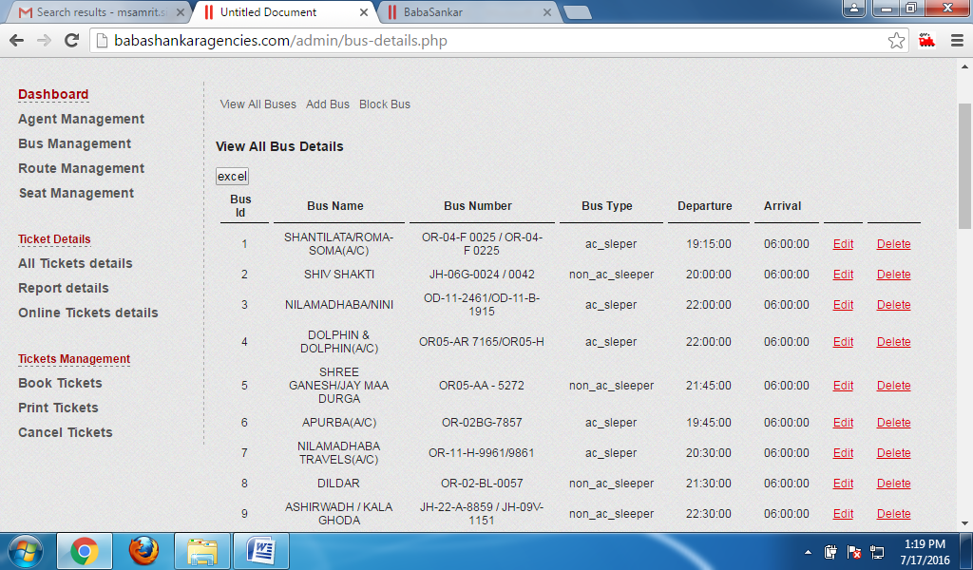

**3. ADD BUS**

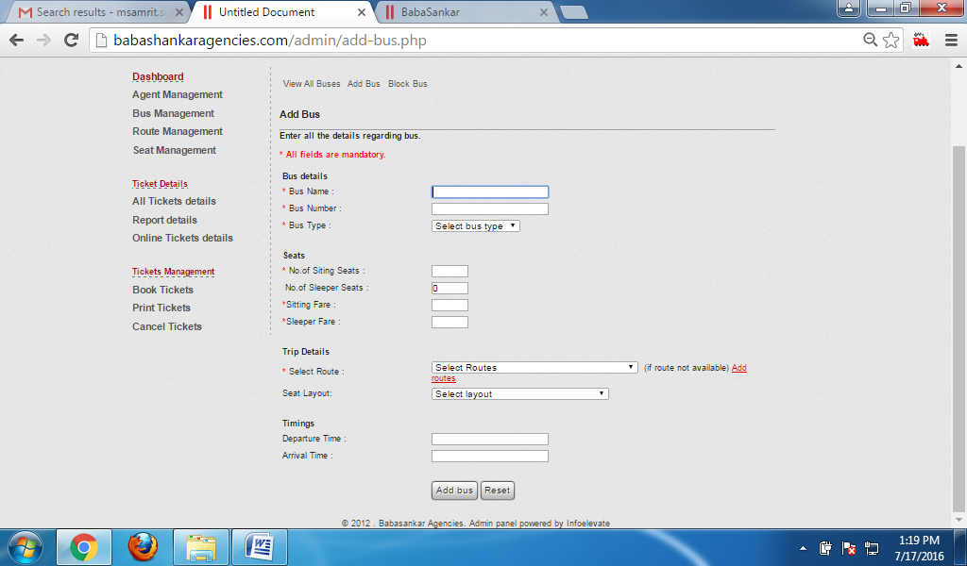

**4.BLOCK BUS**

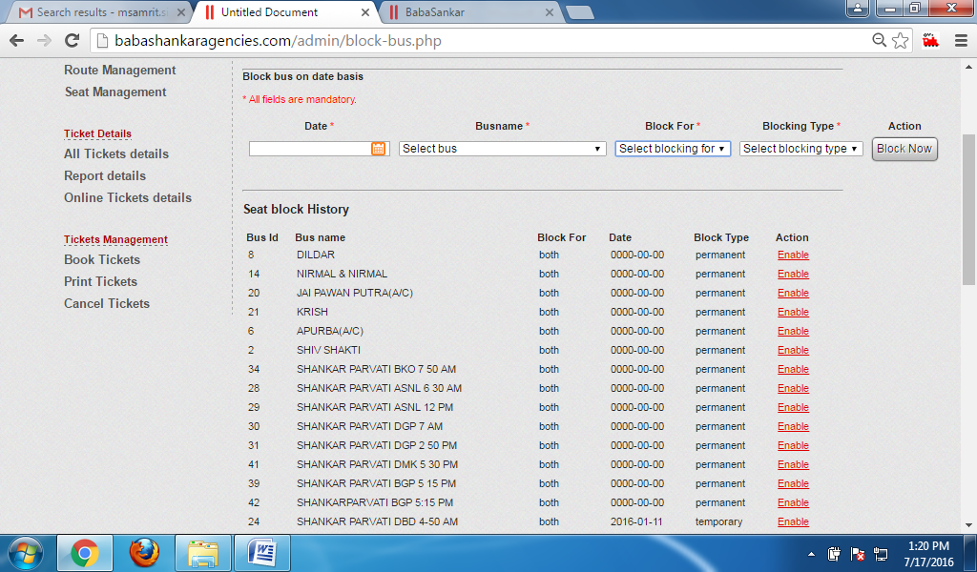

**5.ROOT MANAGEMENT**

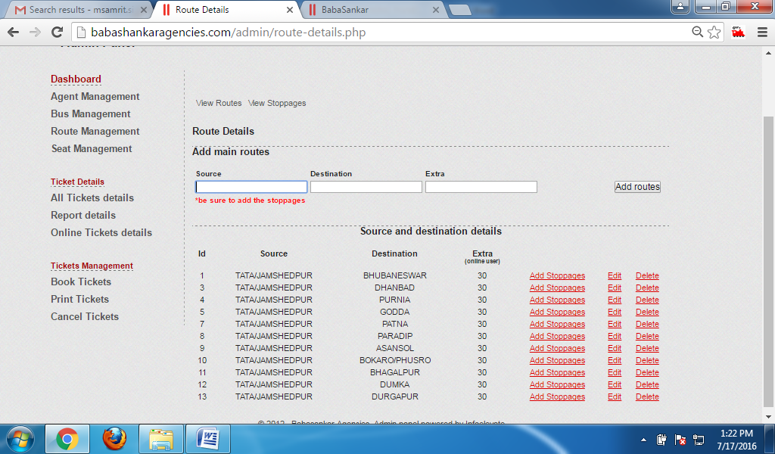

### 7Add Stoppages routes

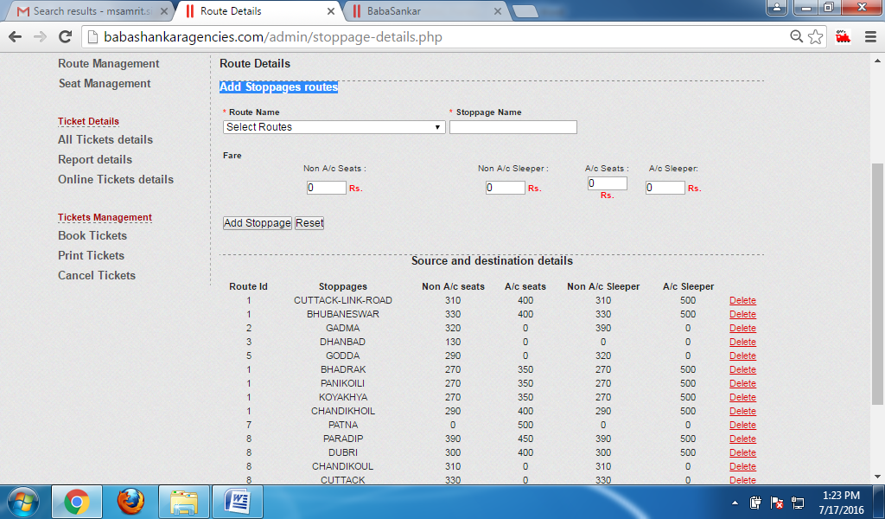

**8.ALL TICKETS DETAIL**

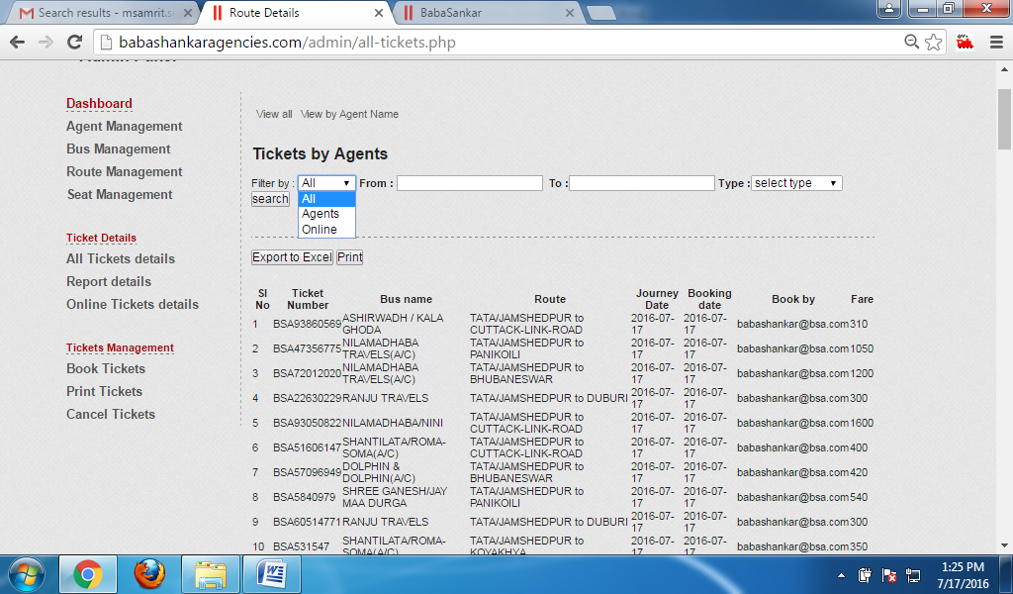

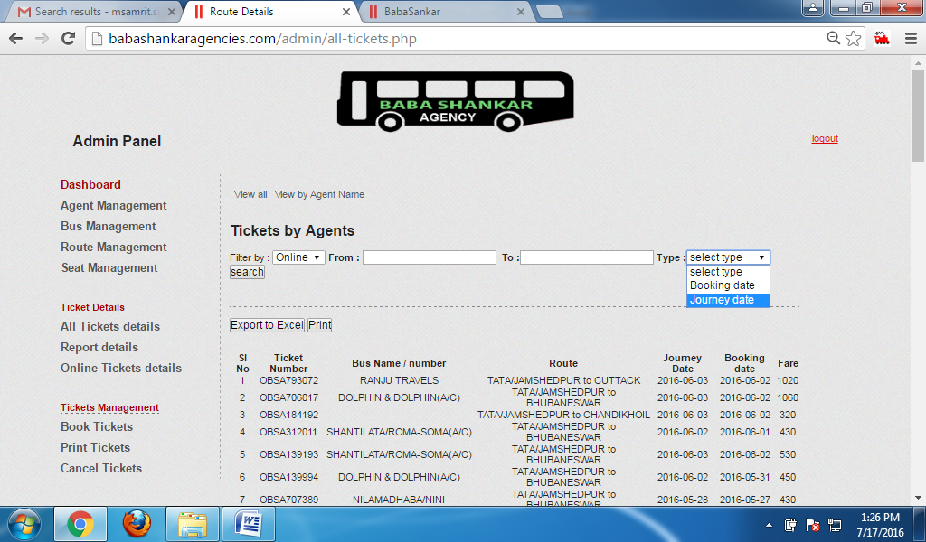

**REPORT DETAILS (END OF THE DAY REPORT)**

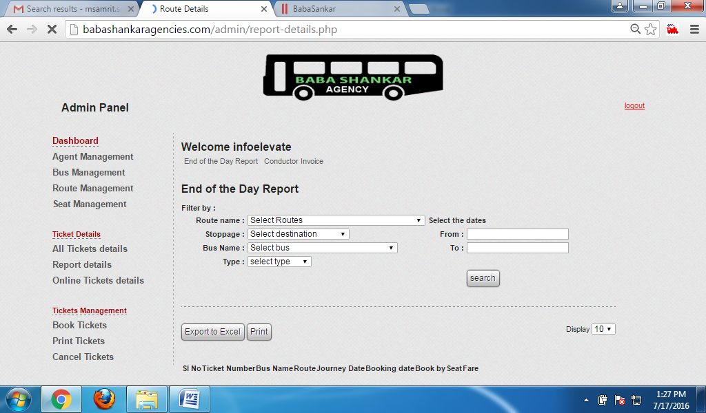

**CONDUCTOR INVOICE**

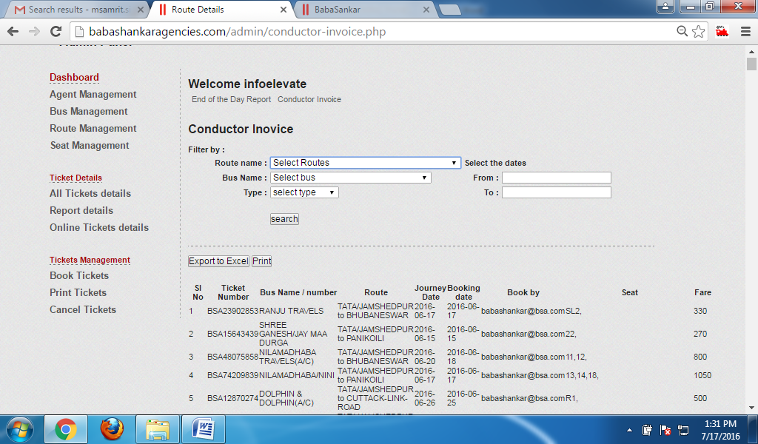

**BOOK TICKETS**

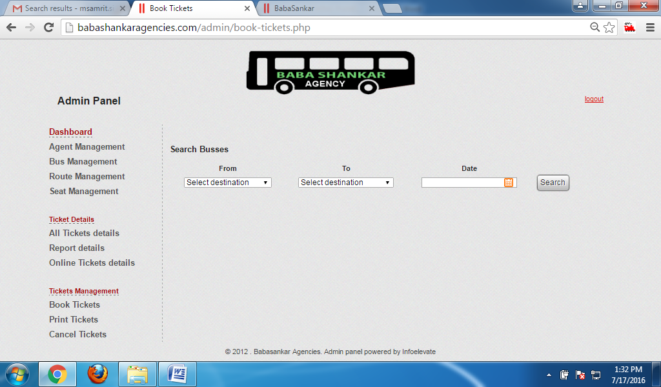

**PRINT TICKET(USER OR AGENT DONO KA TICKETS PRINT AUR CANCEL SIF ADMIN HI KAR SAKTA HAI)**

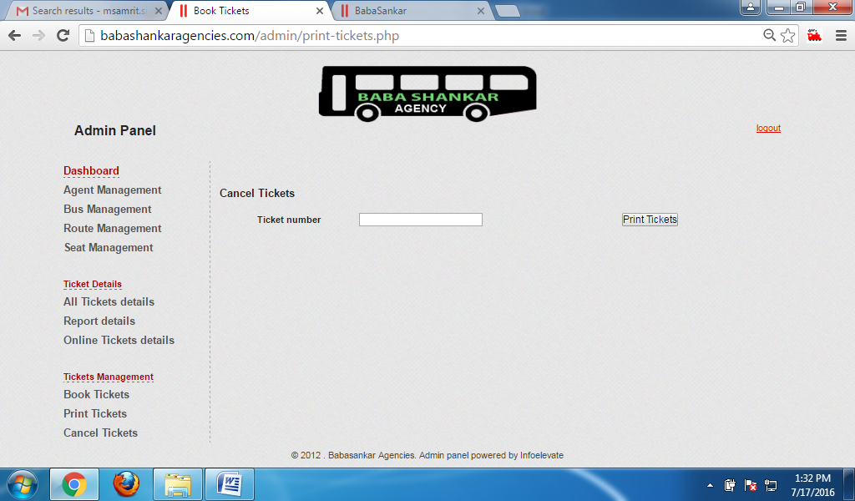

**CANEL TICKETS(SIRF ADMIN PANEL M HI ESA HOGA)**

